1. Tracing route from PC to Router1 & PC to ISP router

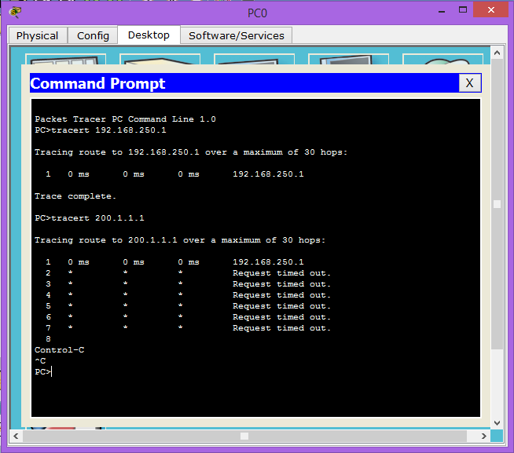

**Result :**

**PC to Router1** : Success

**PC to ISP** : Fail.

Reason : In my opinion, PC failed to reach ISP because as the name “Router” suggests that the device needs to know the path i.e. IP address to respond. PC knows Router1 because it is directly connected to it so request can reach to router1. However, router1 does not know to which path or line it should forward it to.

1. Tracing route from Router1 to PC & Router1 to ISP router

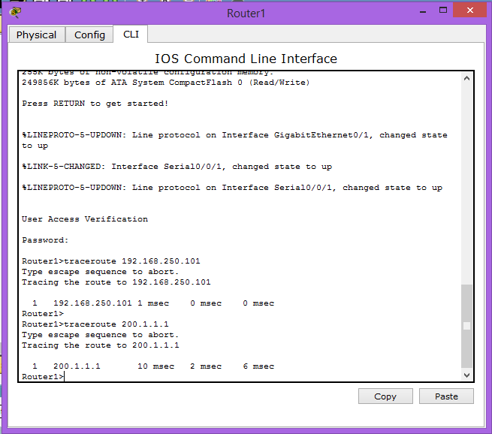

**Router1 to PC & Router1 to ISP** : Both successful

Here both the traces were successful because Router1 is connected directly to both networks so both results are successful.

1. Tracing route from ISP to Router1 & ISP to PC

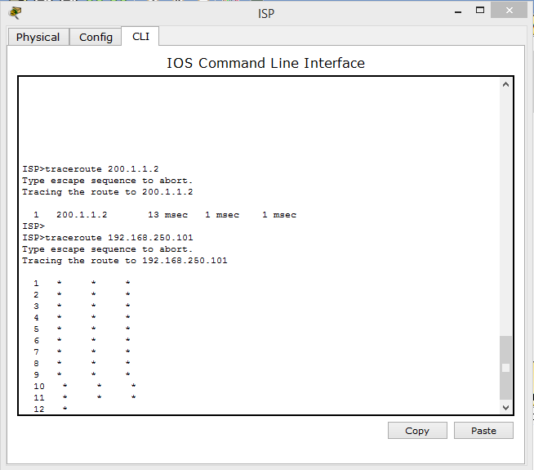

**ISP to Router1** : Successful

**ISP to PC** : Failed

Reason : Here ISP router does not know the network 192.168.250.0 exists as it is not connected with ISP i.e. the network is connected to Router1 & not to ISP. So ISP does not on which line the message should be sent. However, ISP is directly connected with Router1 so the route to Router1 is traced successfully.